# Array and list

Raju Devnath

-~~A~~g~~e~~ndas

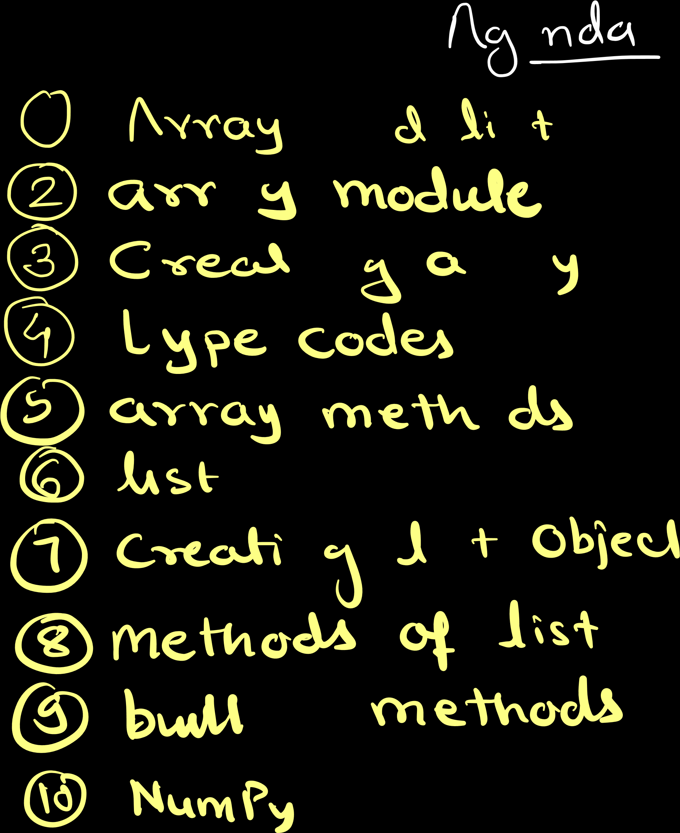~~① A~~rray ~~a~~nd list ② arr~~a~~y module ③ C~~r~~ea~~t~~i~~n~~g a~~rra~~y

⑥ ~~t~~ype codes

1. ~~a~~rray methods
2. list
3. Cr~~e~~ati~~n~~g li~~s~~t objec~~t~~
4. metho~~d~~s of list
5. buil~~t~~-~~in~~ methods

④ Humpy

# Arrayandlmodule~~i~~stbuikt.inbuititins

There are several classes int ~~, f~~loa~~t,~~ Str , list , defined in bu~~i~~lt-in module ~~t~~uple ~~,~~ dict, se~~t,~~range,

bytes ~~,~~ Object ~~,~~ Exception

~~e - ✓~~

~~A~~nother module array

array is not a built-~~i~~n data structure

and therefore need to be imported

array

~~-~~

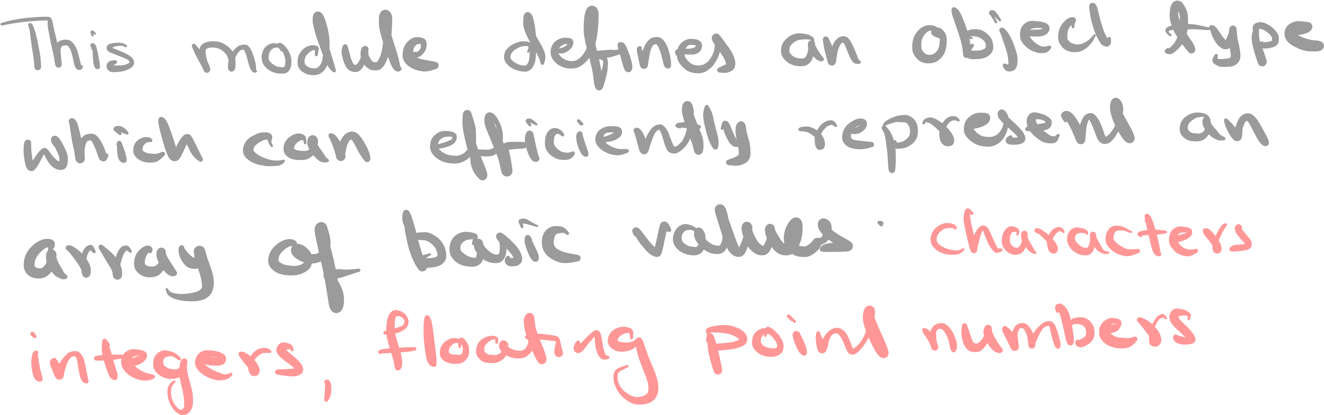This module defines an objec~~t~~ type which can efficiently represen~~t~~ an array of basic values : characters,

integers , floating poin~~t~~ numbers ~~.~~

~~A~~rrays are sequencelists~~t~~ypes, butand very much like behave arrays can have elemen~~t~~s of limited

types

.

Creating ~~A~~stray

- -

from ~~ar~~ray ~~im~~po~~r~~t * at ~~=~~ (type code ~~,~~ [ ~~,~~ ~~e~~l~~e~~m~~e~~n~~ts~~]) ar~~ra~~y

~~ty~~pecode CType

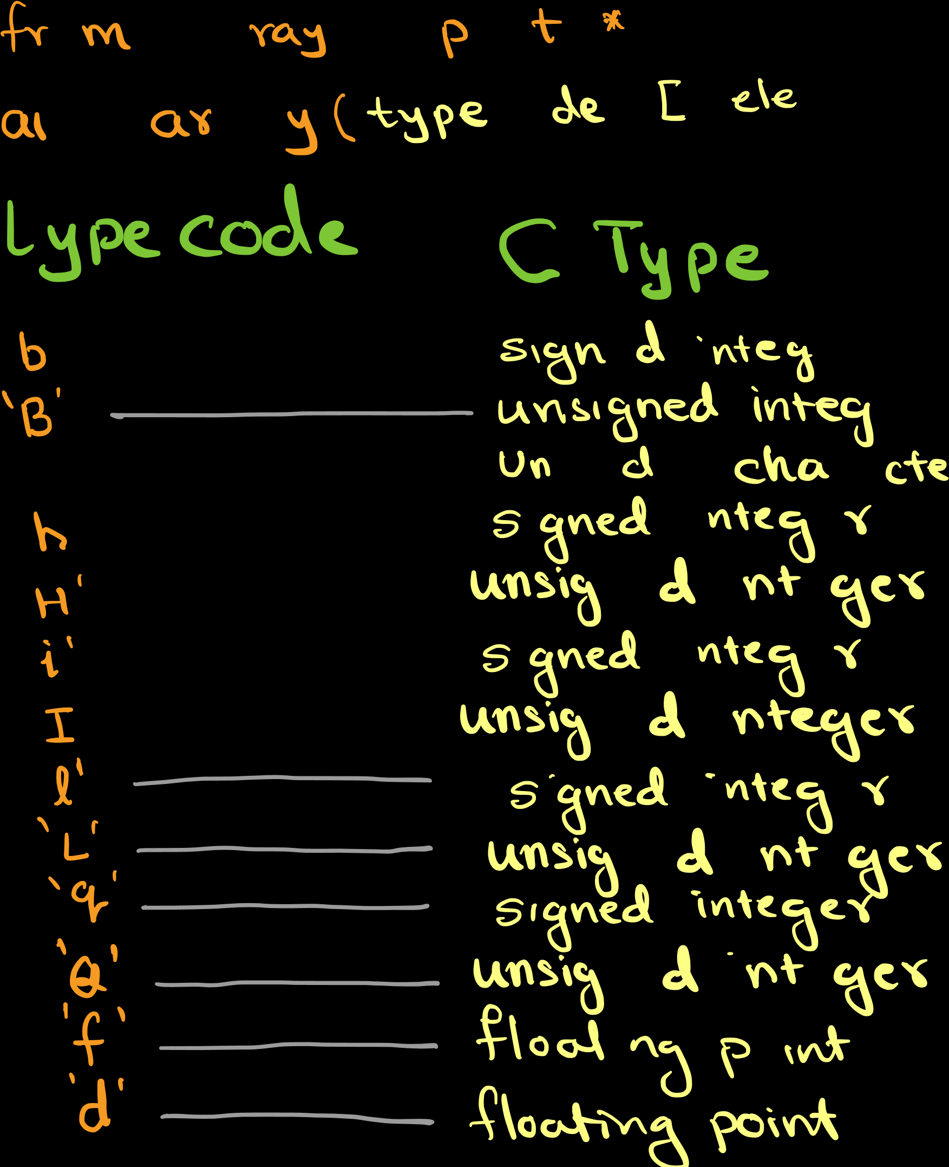~~'~~ b~~' -~~ s~~i~~gn~~e~~d ~~i~~nteg~~er~~ ~~'~~h÷~~'~~ =÷÷÷~~ic:~~od÷;e ÷:

:

"

Un charact~~e~~r unsigned integer

signed integ~~e~~r

: unsig~~n~~ed ~~i~~nt~~e~~ger

÷

'G' unsig~~n~~ed ~~i~~nt~~e~~ger

flo~~at~~ing p~~o~~int

## Exampte

from array import *

at ~~=~~ array ( ~~'~~ i' ~~,~~ [ 5,10 , 15,40] ) for i printin range[(4)i] , :end~~=~~ ' ' 5 10 15 40

)

( at

arraymet.no#

append C)

Coun~~t~~C) extendC)

fromlis~~t~~C) inde~~x~~C) insert C) pop C)

removeC) reversec) to lis~~t~~ C)

### list

list is a class

list is mutable

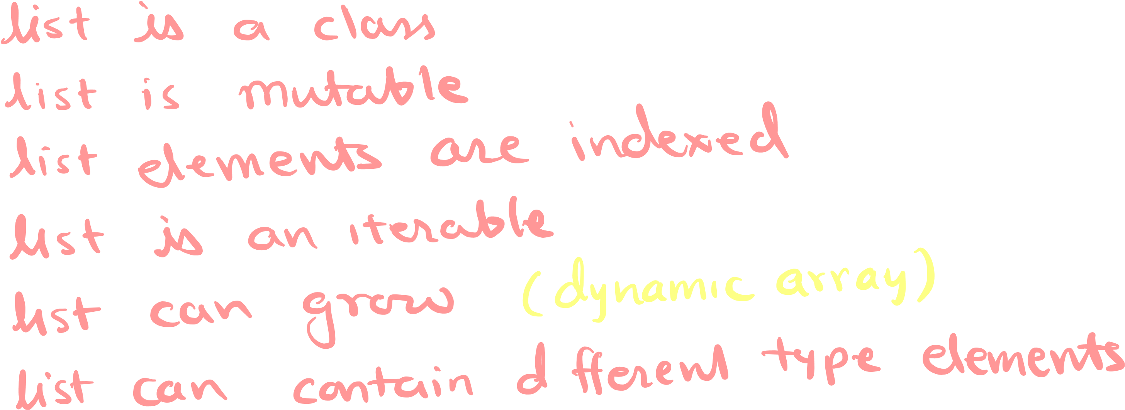list elements are ind~~e~~xed list is an ~~i~~terable list can grow ( dynamic array) list can contain d~~i~~fferen~~t~~ type elements ~~.~~

array

{

• collect~~i~~on of same type elements

* fixed siz~~e~~ 0 1 2 34 size ~~=~~3

I

* indexed

Dynamic array

-

* collect~~i~~on of same type elements
* sizable FFF0 I 2 3 size ~~=~~4 re
* indexed 0 I ↓2 3 45 6 ~~7~~ size ~~=~~ 8

1-7~~-~~-1%-1111

# createlistobjectll-C.IO20 30]

, , l2~~=~~ []

13~~=~~ [ 10 , 5.~~7~~, 'abc~~'~~ ]

methodsofit

appendci

clear C) coun~~t~~C) extendC) index C) inser~~t~~ C)

pop C)

removeC) sort C)

reversec)

b~~uit~~tinmetnods

ten C)

sumC)

Max C) min C)

sortedC)

~~-~~ list and array both are growabk ~~.~~

•list can co~~nt~~a~~in~~ heterogene~~o~~us da~~t~~a

~~.~~ array can contain homogeneous data

IF you wan~~t~~ to perform

mathema~~t~~ical calcula~~ti~~ons ,then

you should use Humpy arrays by importing Humpy package .

Otherwise use lists as it work in a similarway and more flexible to work with~~.~~

Install humpy

open and/ ~~t~~erminal

& Pip install humpy

-

> pips ~~i~~nstall humpy

## tlumpy

import humpy as rip a ~~=~~ np ~~.~~ array ( [42,3 ])

pr~~i~~n~~t~~ (a) to ~~=~~ np ~~.~~ array ( [[11213] ~~,~~ [ 1920,303] )

prin~~t~~ (b) ← 2d array

< ~~=~~ np ~~.~~ a~~r~~ray ([[42133, [ 10,2~~0~~3 ])

prin~~t~~ (C) ← Id array

with two list type

elements